How to Apply the Ethics Scale for Technology Assessment (ESTA)
This guide gives future researchers everything needed to administer ESTA in a new study: the final item wording, the response format, the exact administration procedure used in the validation studies (much of which is not spelled out in the manuscript itself), the layperson theory definitions shown to participants, and pointers to a working reference implementation.
For the full validation evidence (three studies, combined N = 1106), see the article (manuscript) Development and Validation of an Empirical Ethics Scale for Technology Assessment and the rest of this repository.
1. What ESTA measures
ESTA is a multidimensional instrument that captures the degree to which a respondent believes the use of a specific technology is morally acceptable, evaluated in parallel through six classical ethical theories: deontology, utilitarianism, hedonism, virtue ethics, contractualism, and relativism. Each theory is scored as a separate subscale; a second-order factor can also be estimated if a single general "moral acceptability" score is wanted (see the manuscript's external-validity section).
2. Scale structure (final, empirically validated item set)
The final validated set has 41 items across the six theories:
Ethical theory
Items
Relativism
5
Contractualism
6
Hedonism
6
Utilitarianism
10
Deontology
7
Virtue Ethics
7
Total
41
The full item wording is in ESTA_final_items.csv (columns: ethical_theory, item_id, negative_pole_left, positive_pole_right) — use that file as the authoritative item source, not the code referenced in Section 7 below (see the caveat there).
3. Response format
Each item is a bipolar semantic-differential stem rated on a 7-point scale (radio buttons 1–7). There are no separate verbal anchor labels (e.g. no "strongly agree/disagree") — the two endpoints of the scale are the item's own negative and positive pole text. For example, for relativist01:
The technology [replace] ...
1 "...is culturally unacceptable" ○ ○ ○ ○ ○ ○ ○ "...is culturally acceptable" 7
Each item stem completes the sentence "The technology [replace, often previously described within a scenario] ..." with the pole text from the CSV. Note that positive/negative wording is deliberately mixed across items (some items place the ethically-positive pole on the left, others on the right) — this is intentional at the item-design level.
4. Administration procedure
This is the exact procedure used across the validation studies, reconstructed from the lab.js source (Online Study Files/4_SEM/src/js/study.js, ESTALoopComponent) since it is not fully documented in the manuscript:
- One intro screen before any items, framing the task: participants are told that our lives are full of "binding norms of action," that we often instinctively feel a technology is "fair," "just," or "morally right," and that ethical theories offer criteria for making such judgments explicit. They are asked to read carefully and then evaluate the technology from the perspective of each theory in turn. (The continue button is locked for 10 seconds to encourage reading.)
- Six theory blocks, presented in a fully randomized order (re-shuffled per participant, not a fixed rotation or counterbalanced Latin square).
- Each block starts with a definition screen: the theory's name, a one-line description of what it evaluates, an explanatory picture (see Section 5), and the full layperson definition paragraph.
- Then an item-rating screen for that theory's items only, with item order randomized within the block per participant. All items for the theory are shown together in a table, each rated 1–7 as described in Section 3.
- This repeats for all six theories, then the study continues to its next section.
Explicitly, for methodological transparency:
- Theory block order: randomized (Fisher–Yates shuffle), not counterbalanced.
- Item order within each block: randomized, not fixed.
- Item polarity (which pole appears left vs. right): fixed per item as authored, not randomized across participants.

5. Layperson theory definitions
Show one of these before each corresponding item block. Pictures are in ../ESTA wording ethics theories/pictures/.
Intro Screen

Please answer the questions that follow from the perspective of each theory

Our lives are full of binding norms of action, such as that we as humans should not kill other people, cause them pain or suffering, or not rescue people who are in danger. When such norms are violated, we often have a “gut feeling,” for example, we feel revulsion when we see pictures of people suffering.
Similarly, we often instinctively feel that a particular technology is “fair,” “just,” or “morally right.” The central question now is: According to which criteria do we make such judgments? In philosophy, there are so-called ethical theories that attempt to provide a clear idea of how we should morally evaluate a technology. Using different ethical theories to make ethical judgments about a technology illuminates our thinking and presents different perspectives on technologies.
In the following we briefly introduce the ethical theories and ask you to read them as carefully as possible. Then we would like you to answer the questions that follow from the perspective of each theory.

Deontology
Deontology is concerned with the possible violation of central principles or duties:
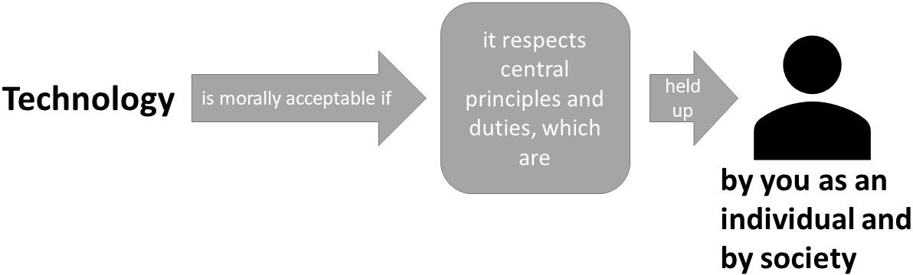

A technology is morally acceptable if it respects basic principles and duties. These basic principles are held up by you as a free and rational person. Your principles are oriented by the guiding statement: "You should act the way you want others to act". When interacting with the technology, upholding your principles is of central importance, not the potential outcomes and consequences of your actions.

Utilitarianism
Utilitarianism is concerned with the consequences for society:

A technology is morally acceptable if it leads to the best outcomes and consequences for society. By interacting with the technology, society aims to maximize overall benefit by increasing utility, decreasing harm or leading to a better world.

Hedonism
Hedonism is concerned with the consequences for you personally:

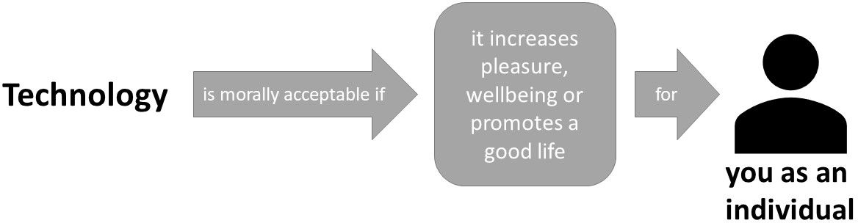

A technology is morally acceptable if it increases pleasure and wellbeing or promotes a good life for you. By interacting with the technology in an instrumental way, you can increase your pleasure, wellbeing or your personal goals.

Virtue Ethics
Virtue ethics is concerned with the moral standards of the technology’s developer:

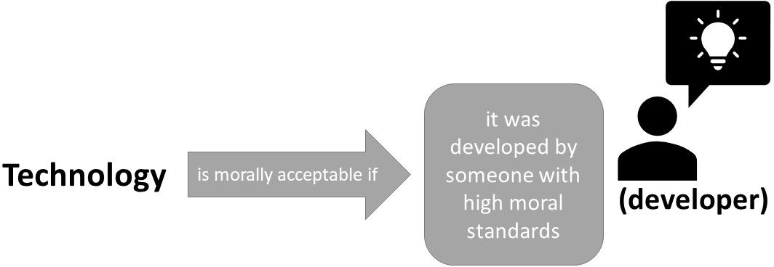

A technology is morally acceptable if it has been developed by someone who has the character and ability to recognize what is morally required. The developer is an upright person with high moral standards, who has developed the technology on the basis of her/his values.

Contractualism
Contractualism asks whether implicit conventions upon which our society generally relies are disregarded or violated:



A technology is morally acceptable if it does not disregard or work against implicit moral conventions that are considered essential to the functioning of a society. To not break moral conventions is in the best interest of all members of a society. For example, in a state where there is “war of all against all”, life would be too insecure and harmful.

Relativism (Relativism.JPG)
Relativism is concerned with the possibility that ethical evaluation differs between groups of people:

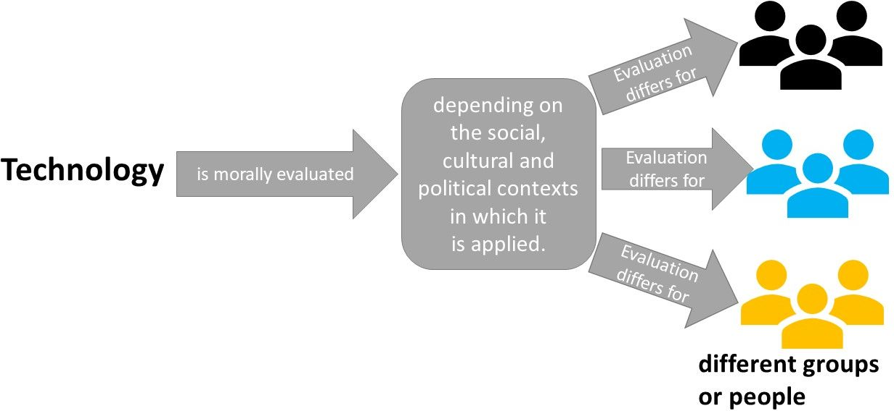

The acceptability of a technology depends on the social, cultural and political contexts in which it is applied. These different contexts influence the standards and procedures by which the use or implementation of a technology is justified.

6. Anchoring ESTA to a technology
Every ESTA item refers back to "the technology" being evaluated, so participants need a scenario text (or some other introduction) describing that technology before they see any items. Worked examples for four technologies (Nano-Pat-Parka, HomeMate, and two framings of Stratospheric Aerosol Injection) are in ../Scenario Texts/folder.
To apply ESTA to a new technology – scenrario approach:
- Write a short scenario (a few paragraphs) describing the technology concretely enough that a layperson can reason about it, following the style of the existing examples.
- Pretest the scenario for comprehensibility and affective neutrality before running the main study (see the manuscript's Study 1, scenario pretesting).
- Present the scenario once, before the ESTA block, and keep a visible reference to "the technology" available throughout (the original implementation keeps this in the page header of every item screen).
7. Reference implementation (lab.js / JATOS)
A full working example is in ../../Online Study Files/4_SEM/src/js/:
- study.js — the ESTALoopComponent (the six-block loop), ESTAtheorydefinition (definition screen), and ESTAscale (item-rating screen, including the 7-point radio-button table rendering).
- globalVar_Scales.js — the shuffleESTA() Fisher–Yates shuffle function used for both block-order and item-order randomization, and the EthicTheories array (definitions, picture filenames, item-ID prefixes).
- globalVar_Text.js — the HTML templates for the intro, definition, and rating screens (ESTAgeninfo, ESTAtheorydefinition, ESTAscale).
Important caveat: the item array in globalVar_Scales.js reflects the item pool as it existed at data collection time, before Study 3's statistical item-purification. It does not match the final 41-item set 1:1 (item IDs overlap but wording differs for several items, and it includes items later dropped). Use ESTA_final_items.csv (Section 2) as your item-wording source; use this code only as the technical pattern for the loop structure, randomization, and response-table rendering — adapt the item data array to the final wording before running a new study.
These files were built with lab.js and were deployed via a JATOS server — see Online Study Files/readme.md for local setup instructions (VS Code Live Server for editing, JATOS export for deployment).
8. Scoring
- Subscale scores: the mean of a theory's items (after reverse-scoring any items where the negative pole is on the right, if you want all subscales to run in a consistent moral-acceptability direction — check negative_pole_left/positive_pole_right per item in the CSV).
- General ESTA score (optional): a second-order factor across the six subscales, as reported in the manuscript's external-validity analysis, recommended only if your design and sample size support fitting that model; a simple mean of the six subscale means is a reasonable proxy otherwise.
9. License
This repository, including this guide and the item list, is licensed under the GNU General Public License v3 (see LICENSE in the repository root).

